 | 12.1.32 Editors - Geometry Nodes Editor - Header - Add Menu - Volume
Table of content
Detailed table of content 1
Add menu - Volume 2
Volume Cube 2
Volume to Mesh 3

Detailed table of content
Detailed table of content
Detailed table of content 1
Add menu - Volume 2
Volume Cube 2
Inputs 2
Geometry 2
Density 2
Background 2
Min: 2
Volume to Mesh 3
Inputs 3
Geometry 3
Density 3
Threshold 3
Adaptivity 3
Properties 3
Resolution 3
Output 3
Geometry 3

´

Add menu - Volume

Here you find nodes to modify the volume.

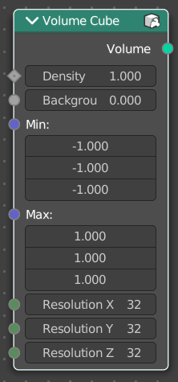
Volume Cube
The Volume Cube node generates a voxel based volume cube primitive that can be used for volume conversion to mesh in conjunction with the Volume to Mesh node.

Inputs

Geometry
Standard geometry input.

Density
Volume density per voxel. Higher values makes it more dense.

Background
Value per voxel outside the cube domain.

Min:
Minimum boundary of the volume cube.
Max:
Maximum boundary of the volume cube.
Resolution X
Number of volume voxules in the X axis.
Resolution Y
Number of volume voxules in the Y axis.
Resolution Z
Number of volume voxules in the Z axis.

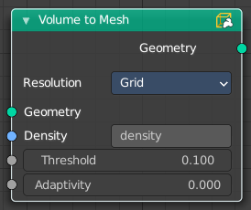
Volume to Mesh
The Volume to Mesh node generates a mesh on the “surface” of a volume. The surface is defined by a threshold value. All voxels with a larger value than the threshold are considered to be outside.
Note that currently this node only works on volumes generated using geometry nodes.

Inputs

Geometry
Standard geometry input.

Density
The density input of the volume object. Either a tag or the information from another node.

Threshold
The voxel amount to use.

Adaptivity
The input radius.

Properties

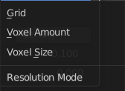
Resolution
Base the voxel resolution at the gridsize, the amount or the size of the point cloud.

Output

Geometry
Standard geometry output.

